INTRODUCTION

Brain-computer interfaces (BCIs) acquire brain signals, analyze them, and translate them into commands that are relayed to output devices that carry out desired actions. BCIs do not use normal neuromuscular output pathways. The main goal of BCI is to replace or restore useful function to people disabled by neuromuscular disorders such as amyotrophic lateral sclerosis, cerebral palsy, stroke, or spinal cord injury. From initial demonstrations of electroencephalography-based spelling and single-neuron-based device control, researchers have gone on to use electroencephalographic, intracortical, electrocorticographic, and other brain signals for increasingly complex control of cursors, robotic arms, prostheses, wheelchairs, and other devices. Brain-computer interfaces may also prove useful for rehabilitation after stroke and for other disorders. In the future, they might augment the performance of surgeons or other medical professionals. Brain-computer interface technology is the focus of a rapidly growing research and development enterprise that is greatly exciting scientists, engineers, clinicians, and the public in general. Its future achievements will depend on advances in 3 crucial areas. Brain-computer interfaces need signal-acquisition hardware that is convenient, portable, safe, and able to function in all environments. Brain-computer interface systems need to be validated in long-term studies of real-world use by people with severe disabilities, and effective and viable models for their widespread dissemination must be implemented. Finally, the day-to-day and moment-to-moment reliability of BCI performance must be improved so that it approaches the reliability of natural muscle-based function.

BRAIN-COMPUTER INTERFACE (BCI)

A BCI is a computer-based system that acquires brain signals, analyzes them, and translates them into commands that are relayed to an output device to carry out a desired action. (E.g. Prosthetic Limb, Bionic Eye, etc.). Thus, BCIs do not use the brain's normal output pathways of peripheral nerves and muscles. This definition strictly limits the term BCI to systems that measure and use signals produced by the central nervous system (CNS). Thus, for example, a voice-activated or muscle-activated communication system is not a BCI. Furthermore, an electroencephalogram (EEG) machine alone is not a BCI because it only records brain signals but does not generate an output that acts on the user's environment. It is a misconception that BCIs are mind-reading devices. Brain-computer interfaces do not read minds in the sense of extracting information from unsuspecting or unwilling users but enable users to act on the world by using brain signals rather than muscles. The user and the BCI work together. The user, often after a period of training, generates brain signals that encode intention, and the BCI, also after training, decodes the signals and translates them into commands to an output device that accomplishes the user's intention.

A Brain-Computer Interface (BCI) is sometimes called as

1. Neural-Control Interface (NCI),
2. Mind-Machine Interface (MMI),
3. Direct-Neural Interface (DNI), or
4. Brain-Machine Interface (BMI).

HISTORY

The history of brain–computer interfaces (BCIs) starts with Hans Berger's discovery of the electrical activity of the human brain and the development of electroencephalography (EEG). In 1924 Berger was the first to record human brain activity by means of EEG. Berger was able to identify oscillatory activity, such as Berger's wave or the alpha wave (8–13 Hz), by analyzing EEG traces.

Berger's first recording device was very rudimentary. He inserted silver wires under the scalps of his patients. These were later replaced by silver foils attached to the patient's head by rubber bandages. Berger connected these sensors to a Lippmann capillary electrometer, with disappointing results. However, more sophisticated measuring devices, such as the Siemens double-coil recording galvanometer, which displayed electric voltages as small as one ten thousandth of a volt, led to success.

Berger analyzed the interrelation of alternations in his EEG wave diagrams with brain diseases. EEGs permitted completely new possibilities for the research of human brain activities.

Although the term had not yet been coined, one of the earliest examples of a working brain-machine interface was the piece Music for Solo Performer (1965) by the American composer Alvin Lucier. The piece makes use of EEG and analog signal processing hardware (filters, amplifiers, and a mixing board) to stimulate acoustic percussion instruments. To perform the piece one must produce alpha waves and thereby "play" the various percussion instruments via loudspeakers which are placed near or directly on the instruments themselves.

In principle, any type of brain signal could be used to control a BCI system. The most commonly studied signals are the electrical signals produced mainly by neuronal postsynaptic membrane polarity changes that occur because of activation of voltage-gated or ion-gated channels. The scalp EEG, first described by Hans Berger in 1929, is largely a measure of these signals. Most of the early BCI work used scalp-recorded EEG signals, which have the advantages of being easy, safe, and inexpensive to acquire. The main disadvantage of scalp recordings is that the electrical signals are significantly attenuated in the process of passing through the dura, skull, and scalp. Thus, important information may be lost. The problem is not simply theoretical: epileptologists have long known that some seizures that are clearly identifiable during intracranial recordings are not seen on scalp EEG. Given this possible limitation, recent BCI work has also explored ways of recording intracranially.

The year 1998 marked a significant development in the field of brain mapping when researcher Philip Kennedy implanted the first **brain computer interface** object into a human being.

GOALS

The main goal of BCI is to replace or restore useful function to people who are disabled by neuromuscular disorders such as, cerebral palsy, stroke, or spinal cord injury.

Brain-Computer Interface research is growing at an extremely rapid rate, as evidenced by the number of peer-reviewed publications in this field over the past 10 years.

POTENTIAL

BCI technology may allow individuals who are unable to speak or use their limbs, to once again communicate or operate assistive devices for walking and manipulating objects, just with thoughts from the brain.

# BCI WORKING

Brain-computer interfaces (BCIs) acquire brain signals, analyze them, and translate them into commands that are relayed to output devices that carry out desired actions. BCIs do not use normal neuromuscular output pathways. The main goal of BCI is to replace or restore useful function to people disabled by neuromuscular disorders such as amyotrophic lateral sclerosis, cerebral palsy, stroke, or spinal cord injury. From initial demonstrations of electroencephalography-based spelling and single-neuron-based device control, researchers have gone on to use electroencephalographic, intracortical, electrocorticographic, and other brain signals for increasingly complex control of cursors, robotic arms, prostheses, wheelchairs, and other devices. Brain-computer interfaces may also prove useful for rehabilitation after stroke and for other disorders. In the future, they might augment the performance of surgeons or other medical professionals. Brain-computer interface technology is the focus of a rapidly growing research and development enterprise that is greatly exciting scientists, engineers, clinicians, and the public in general. Its future achievements will depend on advances in 3 crucial areas. Brain-computer interfaces need signal-acquisition hardware that is convenient, portable, safe, and able to function in all environments. Brain-computer interface systems need to be validated in long-term studies of real-world use by people with severe disabilities, and effective and viable models for their widespread dissemination must be implemented. Finally, the day-to-day and moment-to-moment reliability of BCI performance must be improved so that it approaches the reliability of natural muscle-based function.

Brain-computer interfaces (BCIs) acquire brain signals, analyze them, and translate them into commands that are relayed to output devices that carry out desired actions. BCIs do not use normal neuromuscular output pathways. The main goal of BCI is to replace or restore useful function to people disabled by neuromuscular disorders such as amyotrophic lateral sclerosis, cerebral palsy, stroke, or spinal cord injury. From initial demonstrations of electroencephalography-based spelling and single-neuron-based device control, researchers have gone on to use electroencephalographic, intracortical, electrocorticographic, and other brain signals for increasingly complex control of cursors, robotic arms, prostheses, wheelchairs, and other devices. Brain-computer interfaces may also prove useful for rehabilitation after stroke and for other disorders. In the future, they might augment the performance of surgeons or other medical professionals. Brain-computer interface technology is the focus of a rapidly growing research and development enterprise that is greatly exciting scientists, engineers, clinicians, and the public in general. Its future achievements will depend on advances in 3 crucial areas. Brain-computer interfaces need signal-acquisition hardware that is convenient, portable, safe, and able to function in all environments. Brain-computer interface systems need to be validated in long-term studies of real-world use by people with severe disabilities, and effective and viable models for their widespread dissemination must be implemented. Finally, the day-to-day and moment-to-moment reliability of BCI performance must be improved so that it approaches the reliability of natural muscle-based function.

Brain-computer interfaces (BCIs) acquire brain signals, analyze them, and translate them into commands that are relayed to output devices that carry out desired actions. BCIs do not use normal neuromuscular output pathways. The main goal of BCI is to replace or restore useful function to people disabled by neuromuscular disorders such as amyotrophic lateral sclerosis, cerebral palsy, stroke, or spinal cord injury. From initial demonstrations of electroencephalography-based spelling and single-neuron-based device control, researchers have gone on to use electroencephalographic, intracortical, electrocorticographic, and other brain signals for increasingly complex control of cursors, robotic arms, prostheses, wheelchairs, and other devices. Brain-computer interfaces may also prove useful for rehabilitation after stroke and for other disorders. In the future, they might augment the performance of surgeons or other medical professionals. Brain-computer interface technology is the focus of a rapidly growing research and development enterprise that is greatly exciting scientists, engineers, clinicians, and the public in general. Its future achievements will depend on advances in 3 crucial areas. Brain-computer interfaces need signal-acquisition hardware that is convenient, portable, safe, and able to function in all environments. Brain-computer interface systems need to be validated in long-term studies of real-world use by people with severe disabilities, and effective and viable models for their widespread dissemination must be implemented. Finally, the day-to-day and moment-to-moment reliability of BCI performance must be improved so that it approaches the reliability of natural muscle-based function.

Brain-computer interfaces (BCIs) acquire brain signals, analyze them, and translate them into commands that are relayed to output devices that carry out desired actions. BCIs do not use normal neuromuscular output pathways. The main goal of BCI is to replace or restore useful function to people disabled by neuromuscular disorders such as amyotrophic lateral sclerosis, cerebral palsy, stroke, or spinal cord injury. From initial demonstrations of electroencephalography-based spelling and single-neuron-based device control, researchers have gone on to use electroencephalographic, intracortical, electrocorticographic, and other brain signals for increasingly complex control of cursors, robotic arms, prostheses, wheelchairs, and other devices. Brain-computer interfaces may also prove useful for rehabilitation after stroke and for other disorders. In the future, they might augment the performance of surgeons or other medical professionals. Brain-computer interface technology is the focus of a rapidly growing research and development enterprise that is greatly exciting scientists, engineers, clinicians, and the public in general. Its future achievements will depend on advances in 3 crucial areas. Brain-computer interfaces need signal-acquisition hardware that is convenient, portable, safe, and able to function in all environments. Brain-computer interface systems need to be validated in long-term studies of real-world use by people with severe disabilities, and effective and viable models for their widespread dissemination must be implemented. Finally, the day-to-day and moment-to-moment reliability of BCI performance must be improved so that it approaches the reliability of natural muscle-based function.

Brain-computer interfaces (BCIs) acquire brain signals, analyze them, and translate them into commands that are relayed to output devices that carry out desired actions. BCIs do not use normal neuromuscular output pathways. The main goal of BCI is to replace or restore useful function to people disabled by neuromuscular disorders such as amyotrophic lateral sclerosis, cerebral palsy, stroke, or spinal cord injury. From initial demonstrations of electroencephalography-based spelling and single-neuron-based device control, researchers have gone on to use electroencephalographic, intracortical, electrocorticographic, and other brain signals for increasingly complex control of cursors, robotic arms, prostheses, wheelchairs, and other devices. Brain-computer interfaces may also prove useful for rehabilitation after stroke and for other disorders. In the future, they might augment the performance of surgeons or other medical professionals. Brain-computer interface technology is the focus of a rapidly growing research and development enterprise that is greatly exciting scientists, engineers, clinicians, and the public in general. Its future achievements will depend on advances in 3 crucial areas. Brain-computer interfaces need signal-acquisition hardware that is convenient, portable, safe, and able to function in all environments. Brain-computer interface systems need to be validated in long-term studies of real-world use by people with severe disabilities, and effective and viable models for their widespread dissemination must be implemented. Finally, the day-to-day and moment-to-moment reliability of BCI performance must be improved so that it approaches the reliability of natural muscle-based function.

Brain-computer interfaces (BCIs) acquire brain signals, analyze them, and translate them into commands that are relayed to output devices that carry out desired actions. BCIs do not use normal neuromuscular output pathways. The main goal of BCI is to replace or restore useful function to people disabled by neuromuscular disorders such as amyotrophic lateral sclerosis, cerebral palsy, stroke, or spinal cord injury. From initial demonstrations of electroencephalography-based spelling and single-neuron-based device control, researchers have gone on to use electroencephalographic, intracortical, electrocorticographic, and other brain signals for increasingly complex control of cursors, robotic arms, prostheses, wheelchairs, and other devices. Brain-computer interfaces may also prove useful for rehabilitation after stroke and for other disorders. In the future, they might augment the performance of surgeons or other medical professionals. Brain-computer interface technology is the focus of a rapidly growing research and development enterprise that is greatly exciting scientists, engineers, clinicians, and the public in general. Its future achievements will depend on advances in 3 crucial areas. Brain-computer interfaces need signal-acquisition hardware that is convenient, portable, safe, and able to function in all environments. Brain-computer interface systems need to be validated in long-term studies of real-world use by people with severe disabilities, and effective and viable models for their widespread dissemination must be implemented. Finally, the day-to-day and moment-to-moment reliability of BCI performance must be improved so that it approaches the reliability of natural muscle-based function.

In principle, any type of brain signal could be used to control a BCI system.

The most commonly studied signals are electrical signals from brain activity measured from electrodes (silicon chips) on the scalp, on the cortical surface, or in the cortex.

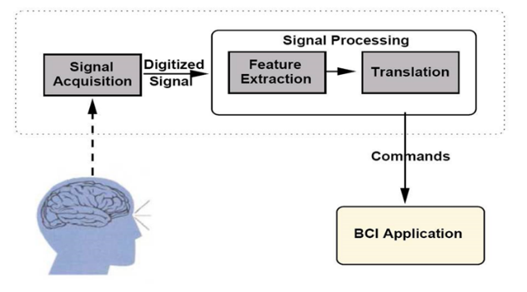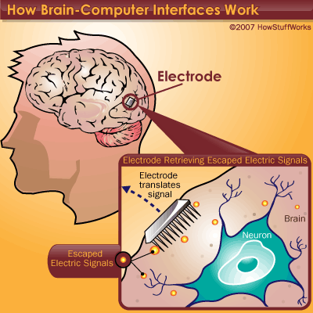

Components of a BCI System

1) Signal Acquisition,

2) Feature Extraction,

3) Feature Translation, and

4) Device Output

These 4 components are controlled by an operating protocol that defines the onset and timing of operation

### COMPONENTS

### **Signal Acquisition**

Signal acquisition is the measurement of brain signals using a particular sensor modality (eg, scalp or intracranial electrodes for electro physiologic activity, fMRI for metabolic activity). The signals are amplified to levels suitable for electronic processing (and they may also be subjected to filtering to remove electrical noise or other undesirable signal characteristics, such as 60-Hz power line interference). The signals are then digitized and transmitted to a computer.

### **Feature Extraction**

Feature extraction is the process of analysing the digital signals to distinguish pertinent signal characteristics (i.e., signal features related to the person's intent) from extraneous content and representing them in a compact form suitable for translation into output commands. These features should have strong correlations with the user's intent. Because much of the relevant (i.e., most strongly correlated) brain activity is either transient or oscillatory, the most commonly extracted signal features in current BCI systems are time-triggered EEG or ECoG response amplitudes and latencies, power within specific EEG or ECoG frequency bands, or firing rates of individual cortical neurons. Environmental artefacts and physiologic artefacts such as electromyographic signals are avoided or removed to ensure accurate measurement of the brain signal features.

### **Feature Translation**

The resulting signal features are then passed to the feature translation algorithm, which converts the features into the appropriate commands for the output device (i.e., commands that accomplish the user's intent). For example, a power decrease in a given frequency band could be translated into an upward displacement of a computer cursor, or a P300 potential could be translated into selection of the letter that evoked it. The translation algorithm should be dynamic to accommodate and adapt to spontaneous or learned changes in the signal features and to ensure that the user's possible range of feature values covers the full range of device control.

### **Device Output**

The commands from the feature translation algorithm operate the external device, providing functions such as letter selection, cursor control, robotic arm operation, and so forth. The device operation provides feedback to the user, thus closing the control loop.

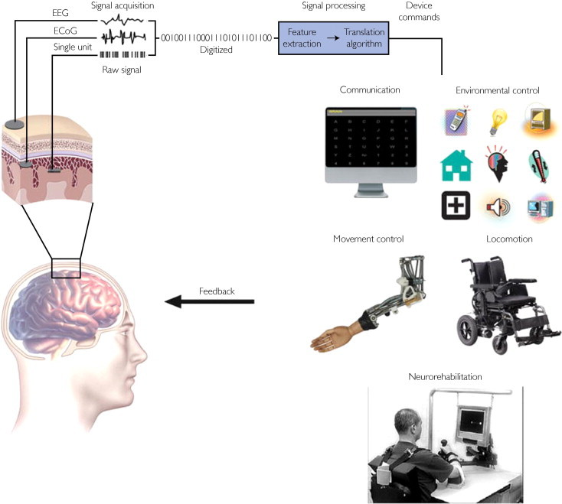

BCI system showing signal detection, processing and command outputs.

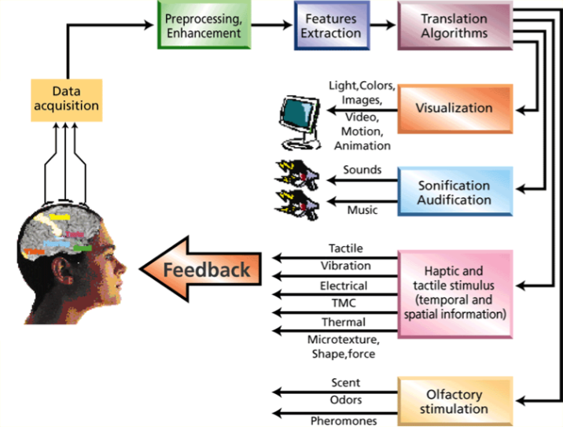

Types of operations done after signals translated

BCI TYPES

BCI system showing signal detection, processing and command outputs.

11

11

1. 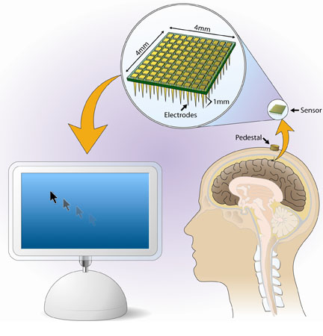**Invasive BCIs :**

* Electrodes are implanted directly into the grey matter of the brain by neurosurgery.
* As they rest in the grey matter, it produces the highest quality of neuron signals among other BCI types.
* But are prone to scar tissue build-up, causing the signal to become weaker or even lost as the body reacts to a foreign object in the brain.

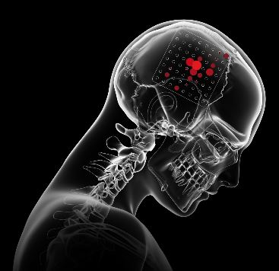

1. **Partially Invasive BCIs :**

* Electrode Grids are implanted inside the skull but outside the grey matter by surgical incision.
* It records the neuron signals of the brain from inside the skull, but from the surface of the brain.
* Electrocorticography (ECoG) is the example of partially invasive BCI.

1. 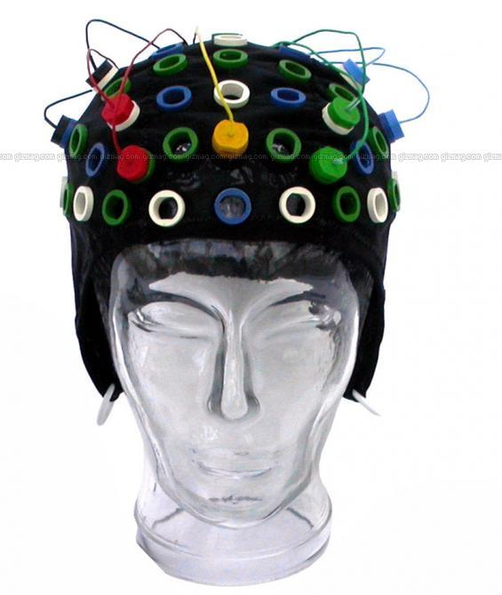**Non-Invasive BCIs :**

* It is the most useful neuron signal imaging method in which electrodes are applied on the outside of the skull i.e. on the scalp.
* It records the activity of the brain externally.

Techniques:-

* Electroencephalography(EEG)
* Magnetoencephalography(MEG)
* functional Magnetic Resonance Imaging(fMRI)

ADVANTAGES

* Allow paralyzed people to control prosthetic limbs with their mind.
* Transmit visual images to the mind of a blind person, allowing them to see.
* Transmit auditory data to the mind of a deaf person, allowing them to hear.
* Allow gamers to control video games with their minds.
* Allow a mute person to have their thoughts displayed and spoken by a computer.

DISADVANTAGES

* Research is still in the beginning stages.
* This technology is still in unrefined state (raw state).
* Ethical issues may prevent its development.
* Electrodes outside of the skull can detect very few electric signals from the brain.
* Electrodes placed inside the skull may create scar tissue in the brain.

FUTURE APPLICATIONS

* Provide additional channel of control in computer games.
* Provide disabled people with communication, environment control, and movement restoration.
* Provide control of devices such as wheelchairs, vehicles, or assistance robots for people with disabilities.
* Control robots that function in dangerous or inhospitable situations (e.g., underwater or in extreme heat or cold).
* Develop intelligent relaxation devices and passive devices for monitoring behaviors such as long-term drug effects, evaluating psychological state, therapeutic methods, etc.
* Monitor stages of sleep, Bionics/Cybernetics, Memory Upload/Download, Dream Capture etc.
* Facebook Brain-Computer Interface for typing and skin-hearing.
* Neuralink - An Initiative by Elon Musk (Neuralink : How the Human Brain Will Download Directly from a Computer).

HIGHLIGHTS

* A brain-computer interface (BCI) is a computer-based system that acquires brain signals, analyses them, and translates them into commands that are relayed to an output device to carry out a desired action.
* In principle, any type of brain signal could be used to control a BCI system. The most commonly studied signals are electrical signals from brain activity measured from electrodes on the scalp, on the cortical surface, or in the cortex.
* A BCI system consists of 4 sequential components: (1) signal acquisition, (2) feature extraction, (3) feature translation, and (4) device output. These 4 components are controlled by an operating protocol that defines the onset and timing of operation, the details of signal processing, the nature of the device commands, and the oversight of performance.
* At present, the striking achievements of BCI research and development remain confined almost entirely to the research laboratory. Studies that seek to demonstrate BCI practicality and efficacy for long-term home use by people with disabilities are just beginning.
* Brain-computer interfaces may eventually be used routinely to replace or restore useful function for people severely disabled by neuromuscular disorders and to augment natural motor outputs for pilots, surgeons, and other highly skilled professionals. Brain-computer interfaces might also improve rehabilitation for people with strokes, head trauma, and other disorders.
* The future of BCIs depends on progress in 3 critical areas: development of comfortable, convenient, and stable signal-acquisition hardware; BCI validation and dissemination; and proven BCI reliability and value for many different user populations.

CONCLUSION

Many researchers throughout the world are developing BCI systems that a few years ago were in the realm of science fiction. These systems use different brain signals, recording methods, and signal-processing algorithms. They can operate many different devices, from cursors on computer screens to wheelchairs to robotic arms. A few people with severe disabilities are already using a BCI for basic communication and control in their daily lives. With better signal-acquisition hardware, clear clinical validation, viable dissemination models, and, probably most important, increased reliability, BCIs may become a major new communication and control technology for people with disabilities—and possibly for the general population also.

As the BCI technology further advances, brain tissue may one day give way to implanting of silicon chips thereby creating a completely computerized simulation of the human brain that can be augmented at will.

Futurists predict that from there, superhuman artificial intelligence won't be far behind…

REFERENCES

* [*www.ncbi.nlm.nih.gov/pmc/articles/PMC3497935/*](http://www.ncbi.nlm.nih.gov/pmc/articles/PMC3497935/)
* [*en.wikipedia.org/wiki/Brain%E2%80%93computer_interface*](https://en.wikipedia.org/wiki/Brain%E2%80%93computer_interface)
* [*www.seminarlinks.blogspot.com*](http://www.seminarlinks.blogspot.com/)
* [*https://interestingengineering.com/neuralink-how-the-human-brain-will-download-directly-from-a-computer*](https://interestingengineering.com/neuralink-how-the-human-brain-will-download-directly-from-a-computer)